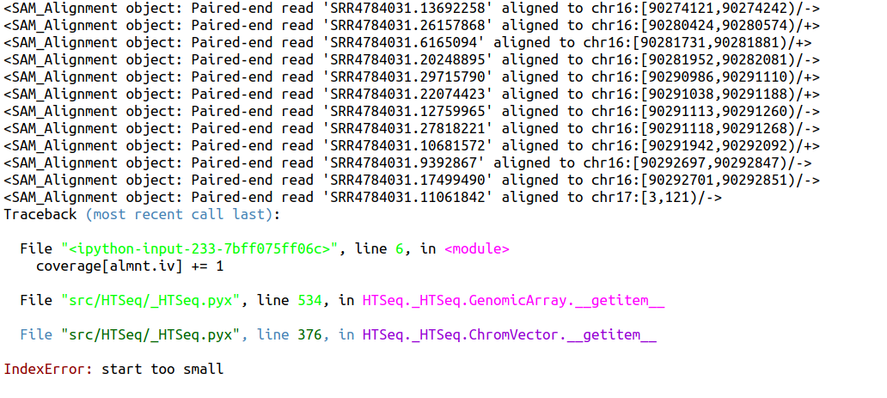
Vì sao ở chr17 lại có start bằng 3???

Một số điều học được từ class Computational genomics của thầy RobEdwards https://github.com/linsalrob/ComputationalGenomicsManual

- Open reading frame:
+ Chỉ có trong khái niệm
+Là chuỗi ATGC mà ko có stop codon
- Từ ORF, ta có thể xác định:
+CDS: coding sequence, và more specific version của CDS là PEG (Protein encoding gene). Chú ý CDS có thể encode của RNA hay tRNA nhưng PEG chỉ là encoding cho protein mà thôi
+CDS thì được transcribe và/hoặc translate

- Hypothetical/putative proteins: protein encoding gene but have not been experimentally proven
- Polypeptide: a stretch around 20--100 amino acids

- Read --> contig --> scafold
- Distribution of sequence (k-mers) are not random: this is the very big problem for genome assembly
- Moreover, genomes are riddled with what we call repeat sequences and a repeat sequence is a stretch of DNA where we have exactly the same DNA occuring at two or more locations on the genome. Repeat sequences can be very short (3 bases) or can be quite long (1.6 kb, in Salmonella with 7 such repeats).
+ To make the matters worse, when you actually grow salmonella, it can switch its DNA around based on those locations
- Sequence similarity search – BLAST
+How do we rapidly search from a database of known sequences for a query, i.e. a newly assemble genome
+This is a difficult problem and it scales with the length of the query sequence and the size of the database
+No make things harder, we are not necessarily looking for exact matches
+Heuristics is often used
+Given the results sequence (that not necessarilyexactly match to the query sequence), how do we evaluate these results, if they have the same identity with the query sequence?
-More dispersed is not good (less change)
+Build indexes for words (k-mer) for searching in database or sequence. The longer k is, the more conservative the k-mer
+Indexing, seed and extend

+Margret Dayhoff
-Protein atlas
-Point accepted mutation
-71 protein families at first
-She calculated the frequencies of going from every amino acid to other amino acid in groups of really closed related proteins. So the idea is let’s let evolution tell us how hard it is for proteins to switch from tyrosine to alanine,…

